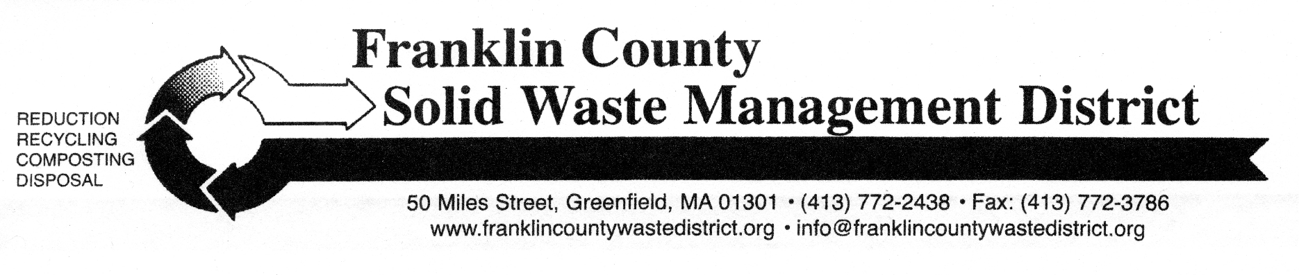

Spring “Clean Sweep” Bulky Waste Recycling Day

Franklin County Solid Waste District’s Spring “Clean Sweep” Bulky Waste Recycling Day is Saturday, May 18, from 9 a.m. to noon, at three locations. The three drop-off sites are: Mohawk Trail Regional School (temporary location for May collection only) at 26 Ashfield Rd (Route 112), Northfield Highway Garage at 49 Caldwell Rd., and Whately Transfer Station at 73 Christian Lane.
Residents from any Solid Waste District member town may bring bulky items such as tires, appliances, scrap metal, furniture, mattresses, carpeting, construction debris, computers, televisions, propane gas tanks, and other large items. Materials will be recycled whenever possible. Residents and businesses do not need to pre-register for the collection.
Disposal fees, cash only, apply for most items. A complete list of prices for the most common items is online at: www.franklincountywastedistrict.org/cleansweep.html, and will also be available at participating town halls, town transfer stations, and the District office at 50 Miles Street in Greenfield.
Clean and dry (bagged) textiles and books accepted free for reuse or recycling.
Did you know? Staples accepts computer equipment (no TVs) free of charge: call store for details and volume limits. Various charities and non-profits accept donations of working electronics, including local Salvation Army and Goodwill stores. Before loading up your car, always call these sites to ask if they can accept your item.
For more information, contact the District office at (413) 772-2438; email info@franklincountywastedistrict.org; or visit: www.franklincountywastedistrict.org.
MA Relay for the hearing impaired: 711 or 1-800-439-2370 (TTY/TDD).
The District is an equal opportunity provider.

