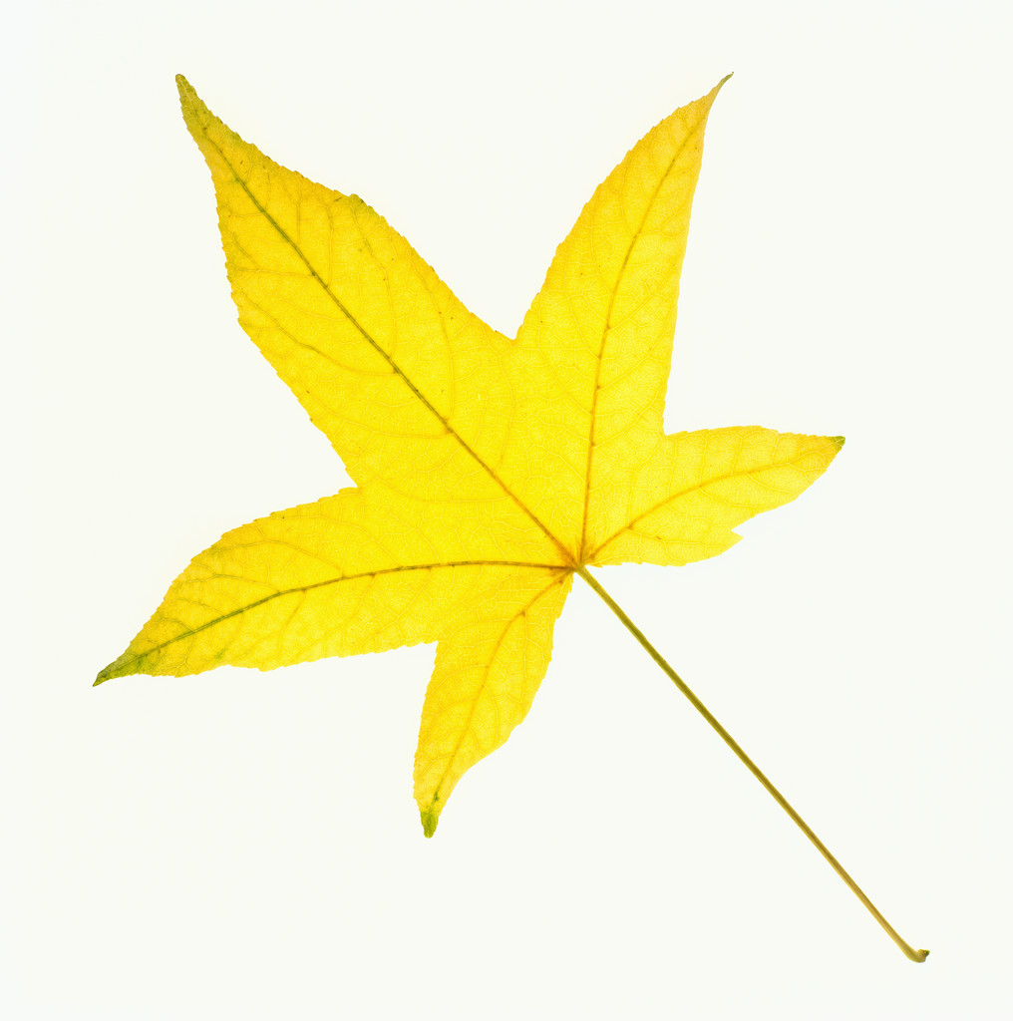
THE SHELBURNE HIGHWAY DEPARTMENT WILL BE
COLLECTING BAGGED LEAVES IN THE VILLAGE ON
MONDAY,
APRIL 29, 2019
(WEATHER PERMITTING)
BAGS CONTAINING LEAVES ONLY SHOULD BE PLACE CURBSIDE BY 7:00 AM

