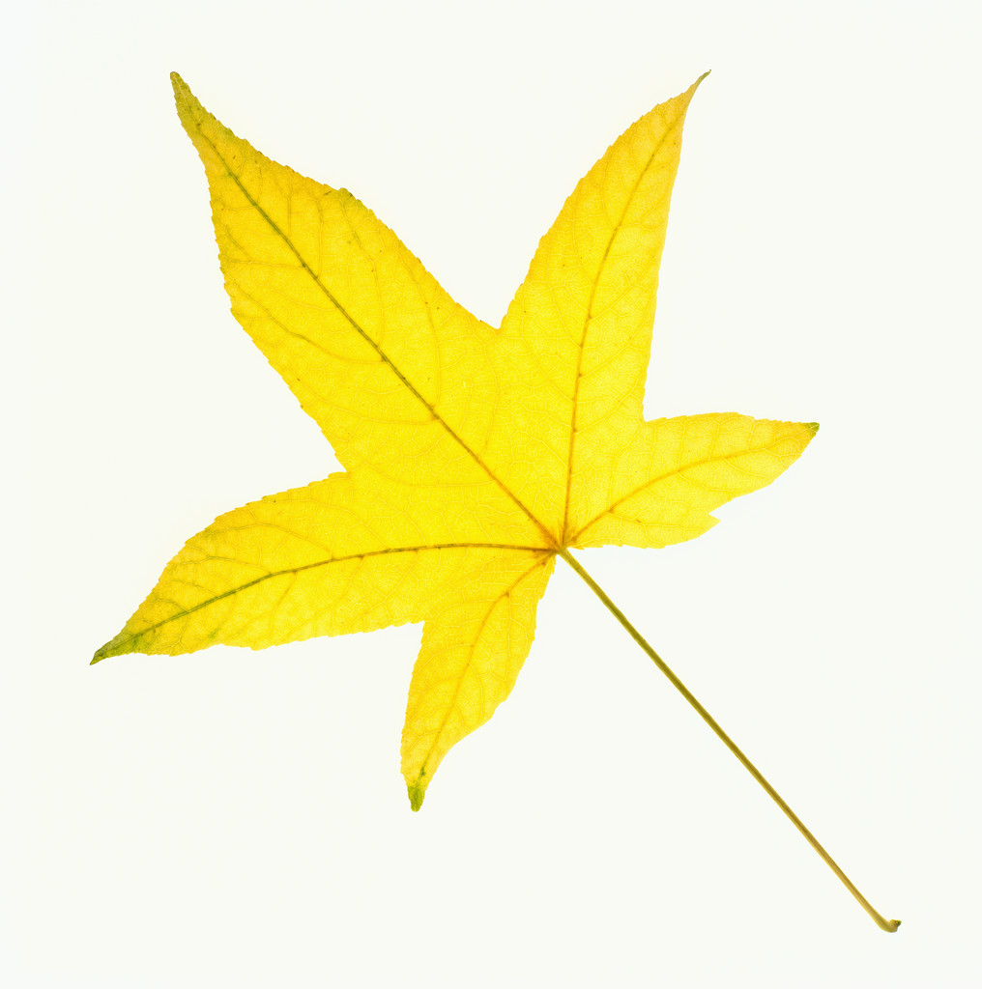
THE SHELBURNE HIGHWAY DEPARTMENT WILL BE
COLLECTING BAGGED LEAVES IN THE VILLAGE ON
MONDAY,
NOVEMBER 14, 2022
(WEATHER PERMITTING)
BAGS CONTAINING LEAVES ONLY SHOULD BE PLACE CURBSIDE BY 7:00 AM

