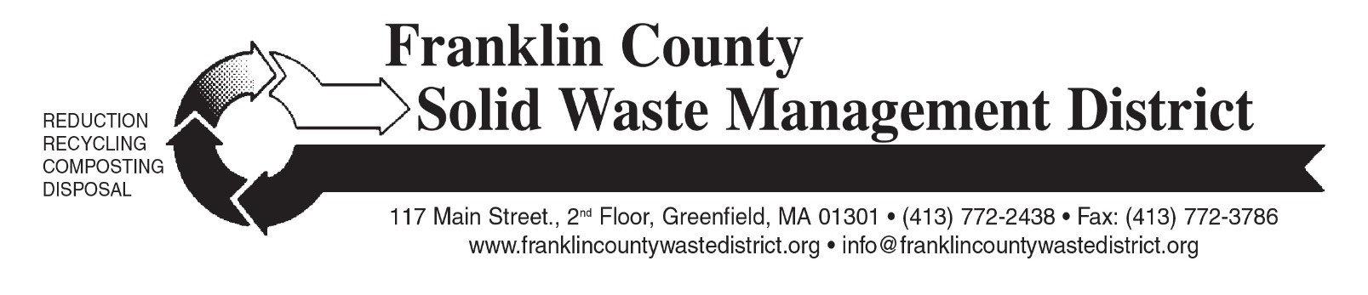

Spring 2023 “Clean Sweep” Bulky Waste Recycling Day

Franklin County Solid Waste Management District is holding the Spring 2023 “Clean Sweep” Bulky Waste Recycling Day on Saturday, May 13 from 9 a.m. to noon. The three drop-off sites are: Mohawk Trail Regional School at 26 Ashfield Rd. (Route 112 South); Northfield Highway Garage at 49 Caldwell Rd; and Whately Transfer Station at 73 Christian Lane.
Residents from any District town may bring bulky items such as tires, appliances, scrap metal, furniture, carpeting, construction debris, computers, televisions, propane gas tanks, and other large items. Materials will be recycled whenever possible.
Mattresses and box springs will not be accepted at this event. In 2022, the Solid Waste District established five permanent drop off locations for mattress recycling across the county. See this webpage for locations, pricing and hours: franklincountywastedistrict.org/mattress-recycling. Call the District office at 413-772-2438 if you are unsure if your mattress and box spring can be recycled.
There are charges for most items. Disposal fees, cash only, will be collected during check-in at each site. A complete list of prices for the most common items is at: franklincountywastedistrict.org. The price list will also be provided to participating town halls and transfer stations. Residents and businesses do not need to pre-register for the collection.
Electronics are accepted at the event, but residents are also encouraged to recycle computer equipment and televisions at their town’s transfer station, or at Greenfield Transfer Station. Staples stores accept computer equipment (no TVs) free of charge: call your local store for details.
Clean, dry textiles and books will be accepted for free reuse or recycling. Textiles must be contained inside a sturdy plastic bag. Textiles are now banned from the trash. Textile recycling accepts 95% of all textiles, including clothing or linens that are torn, stained, with missing buttons or broken zippers. Damaged textiles can be sold to manufacturers that make insulation or shop rags. Acceptable items include CLEAN & DRY clothing, shoes, and accessories; plus curtains, sheets, towels and stuffed animals in any condition (except moldy or wet). Books can be in any condition (except moldy or wet) and can be hardcover or paperback. No encyclopedias.
Bulky Rigid Plastics will be collected separately for a special recycling program; $5 per load. Acceptable items for this special recycling program are limited to these items only: 5-gallon pails, plastic lawn furniture, plastic trash barrels, recycling bins, laundry baskets, storage totes, and milk crates. Bulky rigid plastic items must be empty.
For more information, see franklincountywastedistrict.org, or contact the District office at info@franklincountywastedistrict.org or 413-772-2438. MA Relay for the hearing impaired: 711 or 1-800-439-2370 (TTY/TDD). The District is an equal opportunity provider.

