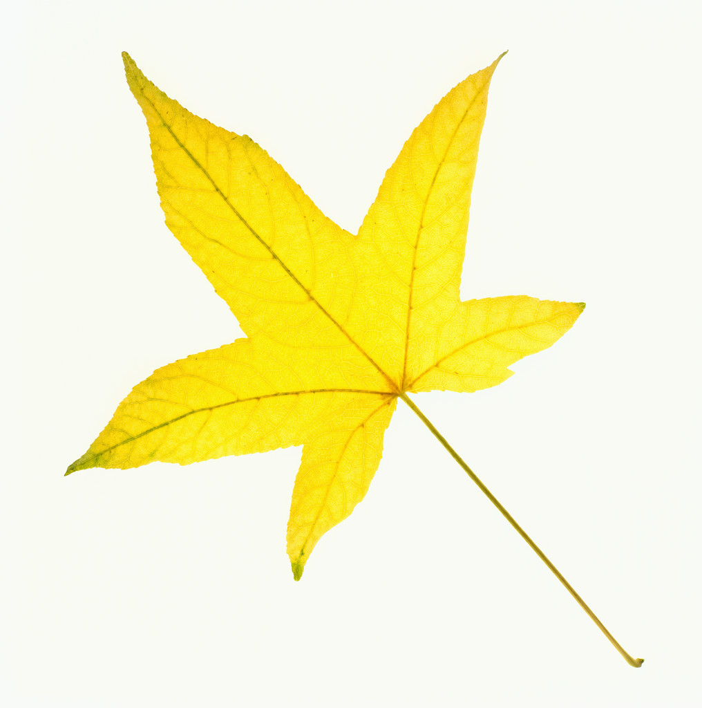
THE SHELBURNE HIGHWAY DEPARTMENT WILL BE
COLLECTING BAGGED LEAVES IN THE VILLAGE ON
MONDAY,
NOVEMBER 5, 2018
(WEATHER PERMITTING)
BAGS CONTAINING LEAVES ONLY SHOULD BE PLACE CURBSIDE BY 7:00 AM

